**NAME:B.NITHESH KUMAR**

**REGNO:192011035**

**1.USE CASE DIAGRAM:**

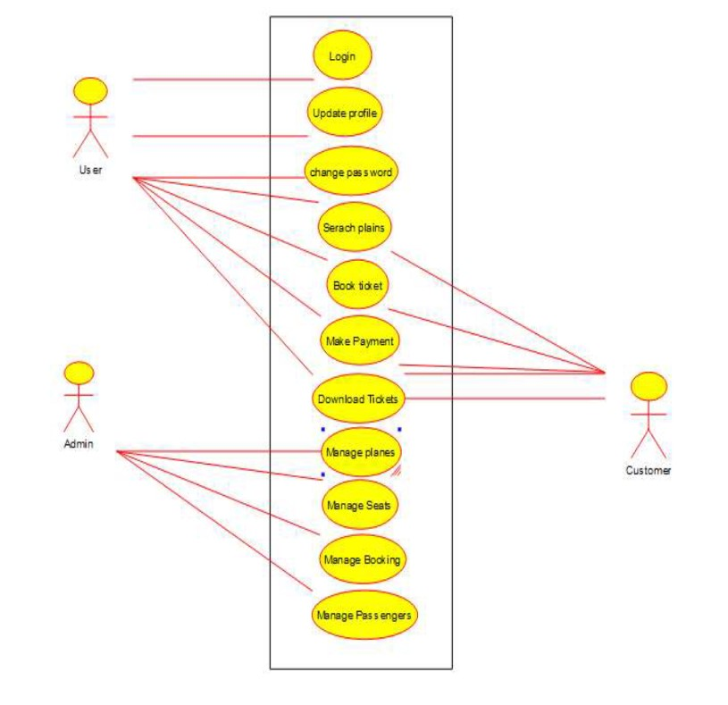

**2. SEQUENCE DIAGRAM:**

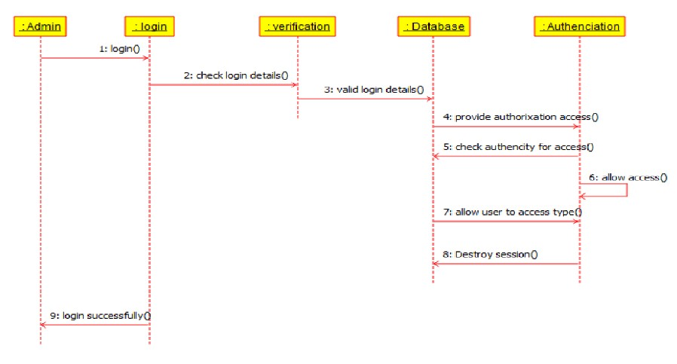

**3. CLASS DIAGRAM:**

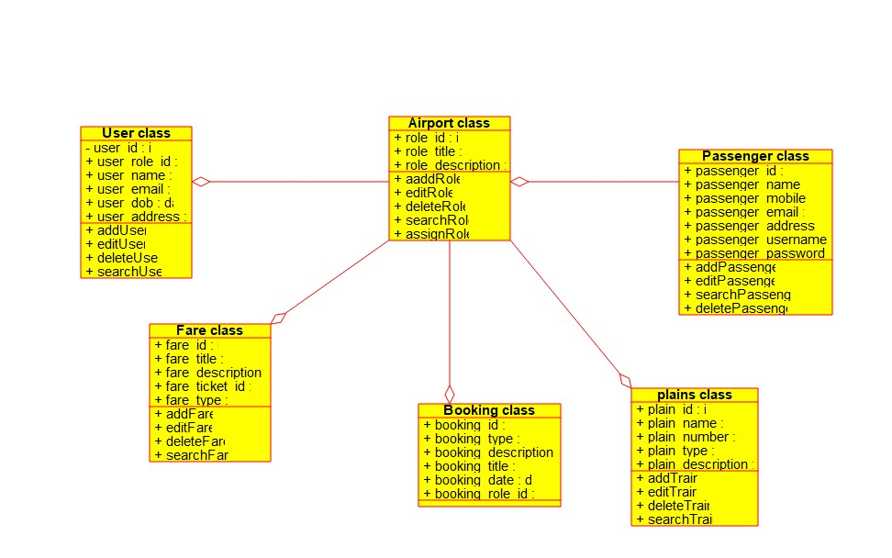

**4. ACTIVITY DIAGRAM:**

